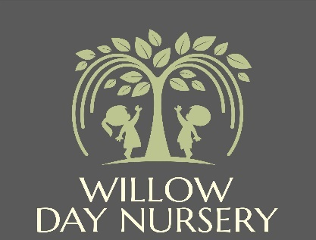

**Willow Day Nursery**

**2A High Street**

**Dodworth**

**S75 3RF**

**Manager: Mrs Victoria Dickinson**

**Deputy Manager: Mrs Katie Fletcher**

**Social Media Policy**

|  |  |
| --- | --- |
| **Date of Next Review** | **January 2026** |

**Social Media and Networking policy**

# Aim

* That our duty to safeguard children is maintained
* That the setting is not exposed to legal risk
* That the reputation of the setting is not adversely affected
* That our users are able to clearly distinguish where information provided via social networking applications is legitimately representative of the setting
* That we do not damage our reputation
* That we recognise our legal responsibilities

Willow Day Nursery recognises that many staff enjoy networking with friends and family via social media. However, we have to balance this against our duty to maintain the confidentiality of children and parents attending our setting, as well as ensuring that our good reputation is upheld.

Staff must remember that they are ambassadors for the nursery both within and outside of working hours and are expected to conduct themselves accordingly when using social media sites.

The internet provides a number of benefits for staff. However, when someone is identified with the setting or discusses their work, they are expected to behave appropriately when on the internet. The principles set out in this policy should always be followed. If in doubt, then details should be discussed in the first instance with the manager.

Social networking sites allow photographs, videos and comments to be shared with thousands of other users. However, it is not appropriate to share work-related information whether written or pictorial in this way.

Staff are in a professional position and are responsible for the care and education of children. Therefore, they must not engage in activities on the internet which might bring the setting or its associated employees into disrepute.

Our use of social networking applications, such as Facebook and Instagram have implications for our duty to safeguard children, young people and vulnerable adults.

# Objectives

This policy covers (but is not limited to) social media platforms such as:

* Twitter
* Facebook
* YouTube
* Tumblr
* Personal blogs and websites
* Comments posted on third party blogs or websites (e.g., Facebook, Bebo, Myspace, Chat roulette)
* Pinterest
* Blogs (e.g., Blogger),
* Discussion forums (e.g., Mumsnet, Ning)
* Media sharing services (e.g., YouTube)
* Microblogging (e.g., Twitter)
* Instagram

All staff should bear in mind that information they share through social networking applications, even though they are on private spaces, are still subject to copyright, GDPR and freedom of information legislation, the Safeguarding Vulnerable Groups Act 2006 and other legislation.

# Social media rules

When using social media sites, **staff must not**:

* Post anything that could damage the nursery’s reputation.
* Post anything that could offend other members of staff, parents or children using our nursery.
* Publish any photographs or materials that could identify the children or our nursery.
* Accept invitations from parents to connect via social media (eg friend requests on Facebook) unless they already know the parent in a private capacity.
* Discuss with parents any issues relating to their child or our nursery. Instead invite the parent to raise the issue when they are next at the nursery, or to contact the Manager if the matter is more urgent.

Any member of staff who posts content or comments that breach confidentiality or which could harm the reputation of our nursery or other staff members, or who publishes photographs of the setting or children, will face disciplinary action in line with our **Staff Disciplinary policy**.

# General cautions for using social media

When using social media in any context it is wise to bear in mind the following points:

* No information published via the internet is ever totally secure; if you don’t want information to become public, do not post it online.
* Once an image or information is in the public domain, it is potentially there forever – the internet never forgets!

# Using computers and storing data

* No information containing personal details of children and families at the setting should be stored on a home computer.
* No photographs of children and families at the setting should be stored on a home computer.
* Photos of children should not be stored on the settings devices for longer than the time necessary to print them off.
* Photos of children should not be stored on the settings devices once printed off.
* The settings devices should be stored safely whilst the setting is closed