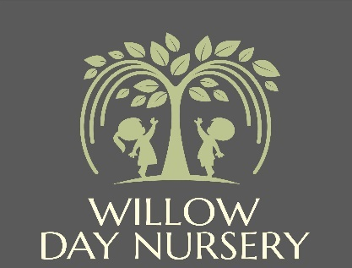

**Willow Day Nursery**

**2A High Street**

**Dodworth**

**S75 3RF**

**Manager: Mrs Victoria Dickinson**

**Deputy Manager: Mrs Katie Fletcher**

**No Smoking, Vaping, Alcohol and Substance Misuse Policy**

|  |  |
| --- | --- |
| **Date of Next Review** | **January 2026** |

**No Smoking, Vaping, Alcohol and Substance Misuse Policy**

At Willow Day Nursery we promote children’s health and wellbeing and the safeguarding of the children in our care. We therefore operate a strict no smoking, vaping, alcohol and substance use policy in and on the premises. This includes the misuse of legal drugs and illegal substance use.

***‘Providers must not allow smoking in or on the premises when children are present or about to be present. Practitioners should not vape or use e-cigarettes when children are present.’ (Department for Education, 2024***

This policy applies to everyone in or on the premises including staff, parents/carers and visitors. This means nobody is permitted to drink or be under the influence of alcohol, use illegal substances, misuse legal substances, smoke, vape or use an e-cigarette in or on Willow Day Nursery premises. There are no designated smoking/vaping areas provided on the premises.

**Staff and Smoking**

Staff who smoke/vape are not allowed to smoke during working hours. If a staff member wishes to smoke/vape they are allowed to do so off the premises during their unpaid break. Staff are required to change out of their uniform to limit odours. At Willow Day Nursery we respect individuals' choice to smoke. We will however provide staff and parents/carers with information about how to stop smoking and vaping if necessary.

**Alcohol and Substance Misuse**

Alcohol and illegal substances are not allowed on Willow Day Nursery premises. If a staff member at Willow Day Nursery appears to be under the influence of alcohol, using illegal drugs or misusing prescription or over the counter drugs they will be told to leave the setting immediately. Disciplinary action will follow.

If a staff member is taking prescription medication or over the counter medication, they must inform the manager immediately. They must also seek advice from a medical professional as to whether the medication will impair their ability to carry out their roles and responsibilities as is expected. If this is the case, they must inform the manager immediately. If a staff member suspects that a parent/carer is under the influence of alcohol or misusing substances and that the safety of the child is compromised, they will follow necessary safeguarding procedures in line with our safeguarding policy.