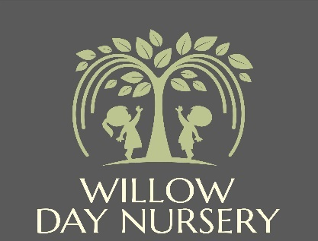

**Willow Day Nursery**

**2A High Street**

**Dodworth**

**S75 3RF**

**Manager: Mrs Victoria Dickinson**

**Deputy Manager: Mrs Katie Fletcher**

**Allergies and Intolerances Policy**

|  |  |
| --- | --- |
| **Date of Next Review** | **January 2026** |

**Allergy policy**

**Purpose of the policy**

All staff at Willow Day Nursery work closely with families to support children with allergies or intolerances.

This policy sets out how we will meet the needs of any child with an allergy or special dietary requirement. We aim for all children with allergies to take a full and active part in nursery life by the careful monitoring of materials and substances used in play and food, and by making necessary adjustments to activities and meals.

Willow Day Nursery also takes staff allergies/intolerances seriously and will do all they can to ensure staff do not come into contact with activities and foods that may affect them.

**Who is responsible?**

It is the responsibility of all staff at the nursery to ensure they know and understand children’s and staff’s allergies and intolerances.

It is the management’s responsibility to obtain information from the parents or staff member with the allergy and complete a care plan with the information on their allergy/intolerance.

In the case of a child, parents are responsible for notifying nursery management if there are any changes to their child’s allergies/intolerance. In the case of a staff member, it is the staff member’s responsibility for notifying nursery management if there are any changes to their allergies/intolerance.

**How we support the inclusion of children with allergies**

We seek information from parents or staff members when they join the nursery regarding any allergies. We will then meet with parents/staff to clarify what the allergy is, what this means for the person with the allergy, what are the signs of a reaction, what procedures the setting needs to follow if an allergic reaction occurs, what steps need to be taken to avoid contact with identified causes of an allergic reaction.

This information is then transferred into a care plan which is then shared with all practitioners. The care plan record is kept in each room for staff to refer to at any time. The nursery regularly checks and updates the allergy chart which is displayed in each room and the kitchen.

The nursery will share the care plans with our meal provider and they will ensure that all foods provided as far as possible do not contain the allergen. If this is not possible the nursery will be notified and put additional measures into place.

**Food**

Staff are very aware of the importance of respecting individual requirements without making children feel awkward or embarrassed; where children must be given something different it is done without fuss, but our preference is all children to eat the same food as far as possible.

The nursery will provide alternatives food for children with different requirements, and plates are colour coded e.g., red for children with allergies.

**Administering of medication due to allergies**

Staff at nursery will always revert to the care plan of the person with the allergy to identify the triggers, and the emergency procedures in the case of an allergic reaction. If a person is suffering from an allergic reaction, staff will follow the emergency procedure.

If medication is to be administered, a senior first aid practitioner will administer the medication and ensure there is someone to witness the administration of medicine. Staff will notify parents as soon as possible and complete an administration of medicine form.

Once the parent/carer arrives, they will read and sign to acknowledge the medication and dosage that was administered. If emergency services are needed or the person with the allergy needs medical assistance, a senior member of staff will travel with them to seek medical attention, and a member of staff at the nursery will inform the parent/carer/ emergency contact.

It should be noted down what triggered the person’s allergy, and any evidence to be taken with them such as food packets with the ingredients labelled.